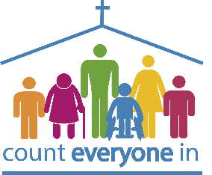
July 2026
Let your conversation be always full of grace, seasoned with salt, so that you may know how to answer everyone. Colossians 4:6 (NIVUK)
I often find it hard to recall whom I have met, where we were and what we spoke about, but perhaps that’s just me. It’s been one of those weeks when people we hardly remember have reminded us of conversations we had a year ago, or maybe longer. They want to pick up where we left off, wanting resources for a friend or relative with learning disabilities or about training for their church. At the funeral of an old friend yesterday, one of the (sadly) few mourners at the graveside committal resumed a conversation started at the deceased lady’s 80th birthday party two years ago!
Jesus spent time with all sorts of people. He welcomed small children, women, disabled people, religious and wealthy people. I’m sure He wasn’t looking over the shoulder of the person talking to Him so that he could see if there was someone more interesting or important to whom He could turn his attention.
In the next couple of months, Pete, Janneke, Becca and I will speak to many people. Firstly, in France at the holiday week at LPO, and then in July at this year’s Keswick Convention. Please pray that our words will be filled with grace and our attitudes with warmth and interest. Let our words be those that build up and encourage. We don’t simply want to communicate information but to demonstrate the love of Jesus for everyone. Some of those conversations may not be memorable for us, but they could make an impression on the other person and lead to much, much more. Only God knows what that might be!
Blessings,

Christine

Welcome to any new readers who have joined us recently. Thank you for your interest, support and prayer. If at any time you wish to unsubscribe from our mailing list, please drop us a line – no hard feelings because we know how quickly our email Inboxes fill up!
Welcome

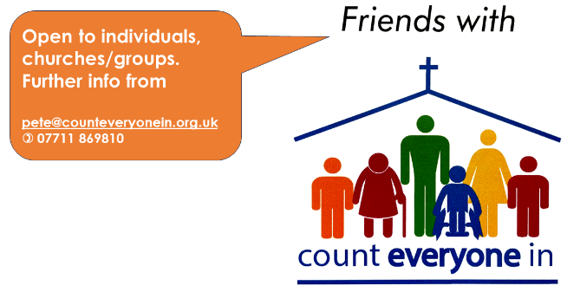
Being Friends
Count Everyone In – so that no one misses out on Jesus
…. and we need each other!
* Email pete@counteveryonein.org.uk if you, your group and/or church
are interested in becoming Friends with Count Everyone In.

Pete will send you an information and application form telling you about
the scheme. Being a Friend also adds you to our monthly half hour prayer Zoom invitation list.
Here is a reminder of the Know and Grow Workshops that we offer at present:
Know & Grow Longing to Belong (in-person) – an introduction to learning disability, theology, communication and how the church can respond
Know & Grow Life Matters (in-person) – supporting adults with learning disabilities as they face issues such as relationships, healing, mental health and bereavement
Know & Grow Makaton (in-person and online) – learn to sign everyday and Christian vocabulary at the only workshop for Christian language that is accredited by The Makaton Charity (TMC). This workshop was developed by Janneke Klos in partnership with TMC.
‘How to Count Everyone In’ (online) an hour-long online session aimed specifically at people who are interested in finding out more about what an accessible church might look like.

Would you and your church be interested in hosting any of these workshops? email: bookings@counteveryonein.org.uk

Click on the links below to book your place:

Know and Grow Makaton in King's Lynn (Terrington St Clement) - 27th June - Know and Grow Makaton - King's Lynn (27-Jun-2026) · CharitySuite Events

Know and Grow Life Matters in Melksham – 3rd October
Know and Grow Life Matters - Melksham (03-Oct-2026) · CharitySuite Events

‘How to Count Everyone In’ – 14 September - online
CEI Online Seminar - How to Count Everyone In (14-Sept-2026) - Charity Suite Event

OR email bookings@counteveryonein.org.uk

More Makaton training? Have you ever thought about it?

Did you know that Janneke also runs Generic Makaton. Why not join her on her next Makaton Level 1 workshop that will be delivered across three Wednesday evenings in June/July - 6.30pm - 9pm. Price is £85. You must attend all three evenings.

Book by emailing Janneke - Yonka.Klos@outlook.com

Wednesday 17th June
Wednesday 24th June
Wednesday 1st July


Thank you!

Without you, your prayers, interest, time and financial support it would be hard for us to do what God has called us to do. Thank you for whatever part you play in supporting Count Everyone In. We don’t receive any funding apart from that of individuals and churches, and no contribution is too small. Thank you too, to all our anonymous givers; you know who you are!
Donations to Count Everyone, regular or one-off, In may be made at http://www.give.net/20280624 or directly into Metro Bank (business) account (Gift Aid form available on request) Sort code: 23 05 80 - Account no: 33248601

Prayer
Friends with Count Everyone In Zoom prayer meetings continue on Thursday 25th June and we will send out the Prayer points and Zoom Links in due course. Here are some prayer points for this month:

- Praise for recent Know and Grow Workshops in Reading, Clevedon, Midsomer Norton and those online
- Pray for the holiday week at Le Pas Opton, France, 1st-8th June, for fun, friendship and building of faith for us all, with safe travel and good health
- Pray for preparation for the Keswick Convention, for our volunteers, guests and their families, also those who will visit the exhibition
- Continued prayer for Friends groups as they plan their summer programmes
Regional prayer - especially for churches in the big cities such as London, Birmingham and Leeds where we have few contacts but there are many people with learning disabilities.

Resources
We have a wide range of resources including a New Testament and also Psalms, both NIrV - Accessible Edition (softback). Please see the attached Resources list for further information

Diary dates – please note that the CEI team normally meets on Thursdays

1-8 Jun Spring Harvest Holidays – France (travel dates 30/31 May)
25 Jun CEI Friends Prayer Zoom
27 Jun Know and Grow Makaton – Terrington St Clement, King’s Lynn
28 Jun Holy Trinity, Redhill
4 Jul CEI Trustees’ Meeting
12 Jul Christ Church, Guildford
20 - 24 Jul Keswick Convention week 1- CEI Celebration programme
25 July NO PRAYER ZOOM – CEI team at Keswick
18 – 31Jul Keswick Convention weeks 1 & 2 - exhibition and seminars
11 Oct Fenland Community Church, March
14-15 Oct Christian Resources Exhibition – Sandown Park, Esher
15 Nov Fenland Community Church, March
6 Dec CEI – Christmas Celebration, St Nics, Newbury and on-line

GDPR We hold your contact details for the purpose of sending you this newsletter at your own request. We also hold details of people who serve on CEI teams or attend training days. If you have any questions about this, or you wish to be removed from mailing lists etc, please let us know.

- Give as You Live is one way to donate to CEI at no extra cost to you – https://www.giveasyoulive.com/

- CCLI Don’t forget to include ‘Prospects’ and ‘Worship for Everyone’ songs in your Church Copyright Licence (CCLI) reporting

Social media - See www.counteveryonein.org.uk and you can also keep up with us on Facebook, X & Instagram. Please Follow, Like, Comment and Share so that more people find out about CEI.

Every blessing,
Pete, Christine, Janneke and Becca

Pete: 07711 869810 pete@counteveryonein.org.uk
Christine: 07751 431277 christine@counteveryonein.org.uk
Janneke: janneke@counteveryonein.org.uk
Becca: becca@counteveryonein.org.uk
www.youtube.com/c/counteveryonein

Copyright © 2026 Count Everyone In, All rights reserved.
Registered charity number 1181852

Our postal address is: Count Everyone In · 34 Enborne Road · Newbury RG14 6AH · UK

